Royal Ordains

**Medieval fantasy side-scrolling beat’em up**

A concept of history meet modernity

# Game Idea and competitors

Royal Ordains is a side-scrolling action (Beat 'em up) game with RPG and historical education elements. The game setting is based on the Medieval period but mixed with a high fantasy setting to captivate a wider audience. The art style of the game aims to imitate the art style of Illuminated manuscripts from the Medieval period. This concept of adapting/incorporating traditional art style (Medieval manuscript art in particular) for video games is something that has rarely been done before.

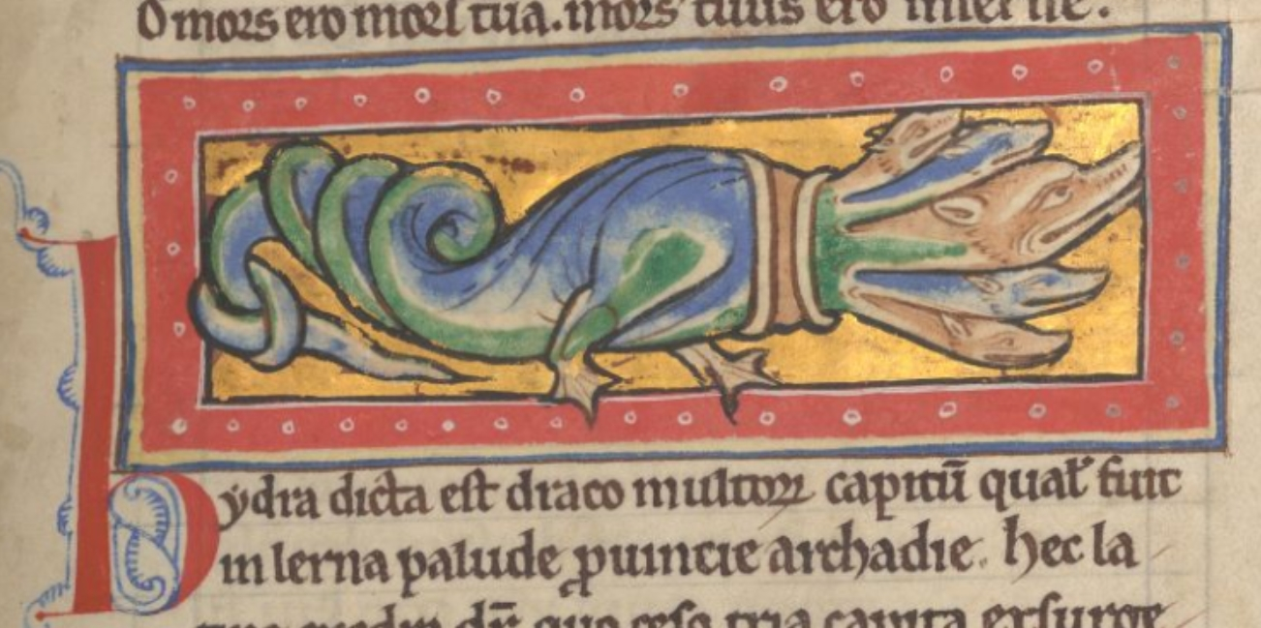

**Figure 1:** A hydra from *The Worksop Bestiary MS M.81*

This concept of Medieval art style adaptation, however, recently saw a small beginning in adaptation for historical games such as Pentiment (story-driven RPG game by Obsidian studio) and Inkulinati (Turn-based strategy game by Yaza Games). However, both of the examples are in a different genre from this project, and there have been no games of a similar genre as this project attempt to accomplish this feat. Hence, there would be no direct competitor in the market.

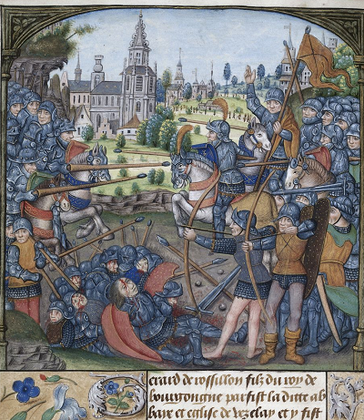

**Figure 2:** A battle scene from *Detailed record for Yates Thompson 32*

In terms of gameplay, the 2D side-scrolling beat 'em up is one of the most popular genres for the action game market, especially in indie game development. The most recent and closest competitors/comparisons to this game would be Tails of Iron1, Salt and Sanctuary2, and Blasphemous3. For the game to differentiate from the current game market, in addition to the unique art style, the game will focus on the gameplay of combat mechanics and keep the level of platforming to a minimum. The game will be in true 2 dimensions in terms of movement, unlike many other beat’em up genre games where players can move up and down on the stage in a 2.5 Dimension manner.

# Game Overview

## Main Objective

* To let the player learn about medieval history, illuminated manuscript art making, whilst also having fun with a simple to learn but highly engaging gameplay.
* Provides a challenge to player with varied difficulty level that test their skill

## **Genre**

* Action/Beat’em up
* 2D
* Medieval Fantasy
* Single Player
* RPG
* Multiplayer (Co-Op and optional PVP)

## **Control**

AD = Move right and left

S = Couch

W = Jump

J = Weak Attack

K = Strong Attack

L = Block

I = Special Move

U = Item

O = Emote

ESC = Pause game/ Learning mode

Royal Ordains is a side-scrolling action game where a player takes control of one character who at the request/employment from the King to save the Masendor Kingdom from various threats throughout the decades. The game’s gameplay and graphic are in 2 dimensions with art style similar to that of Medieval Manuscript. The game’s mood and graphic will be brutal and gory most of the time, especially in combat. The character animation will be vector based and each body part will have its own hitbox to calculate the most accurate sprite collide detection. The game allows upto 4 maximum players per session, with control of either a keyboard and/or joysticks. The number of monsters on screen/stage should be at the maximum of 100 at a time. The game will be designed for Personal Computer Operating Systems (Windows, MacOS, and Linux) in its first release, and potentially console or mobile later.

The art style will be similar to that of the medieval manuscript, which is linked to the story of the king employing a chronicler to record the heroes' activities and their deeds in real time as a reward for embarking on such glorious quests. As the game story and events will be narrated by a narrator (the manuscript's scribes), the game also explores the concept of what/how the people in medieval fantasy would record the story in manuscript, considering that monsters and legends are the reality over there.

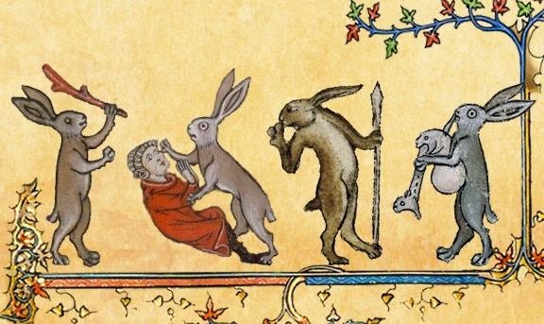

**Figure 3:** Killer rabbits commonly found in Medieval manuscripts

The game will consist of 12 playable characters, which have diverse play-style. The player then controls the character to fight in a chapter-based mission against various types of foes, from bandits to monsters. Each character has different strengths, attacks, combos, and special abilities.

The game provides a challenge to the player with a list of pre-set chapter missions. When player start the game from scratch, they can create a save slot and select one of the 12 available characters, which start from level 1. Player can level up their character each time they complete a mission, each level give a stat and skill points that player can allocate to improve the character and unlock new skills/combos.

During the mission, the game can trigger multiple random encounter/stage/weather that can positively or negatively affect players in some way. For example, a dragon may flyby and breath fire to a specific section of screen capable of damaging both players and enemies alike. Another example is a travelling merchant setting up shop for player during the mission.

The gameplay consist of two states for player: town area for player to learn about the game story/lore, purchasing/selling items, train, take side quests, selecting already played mission, or starting a new chapter. After selecting a mission, the player character will move to the first stage of the first mission of the selected chapter. Then they will attempt to accomplish the stage’s main objectives to win and able move to the next stage (or they can choose to return to town after). Each chapter will have multiple stages, and each stage may introduce new mechanic and monsters or new combinations of both. Each finished chapter will progress the game time and unlock a new look for the character.

The story will start with a typical beginning of most fantasy story, a king ask a group of hero to fight against the multiple threats to his kingdom. Although the kingdom does provide (a meagre) funding and equipment for the group at first, they will be rewarded greatly if they can eradicate the threat (at the end of the chapter). The story will later become more complex and the cliche trope story will be more than what it seems.

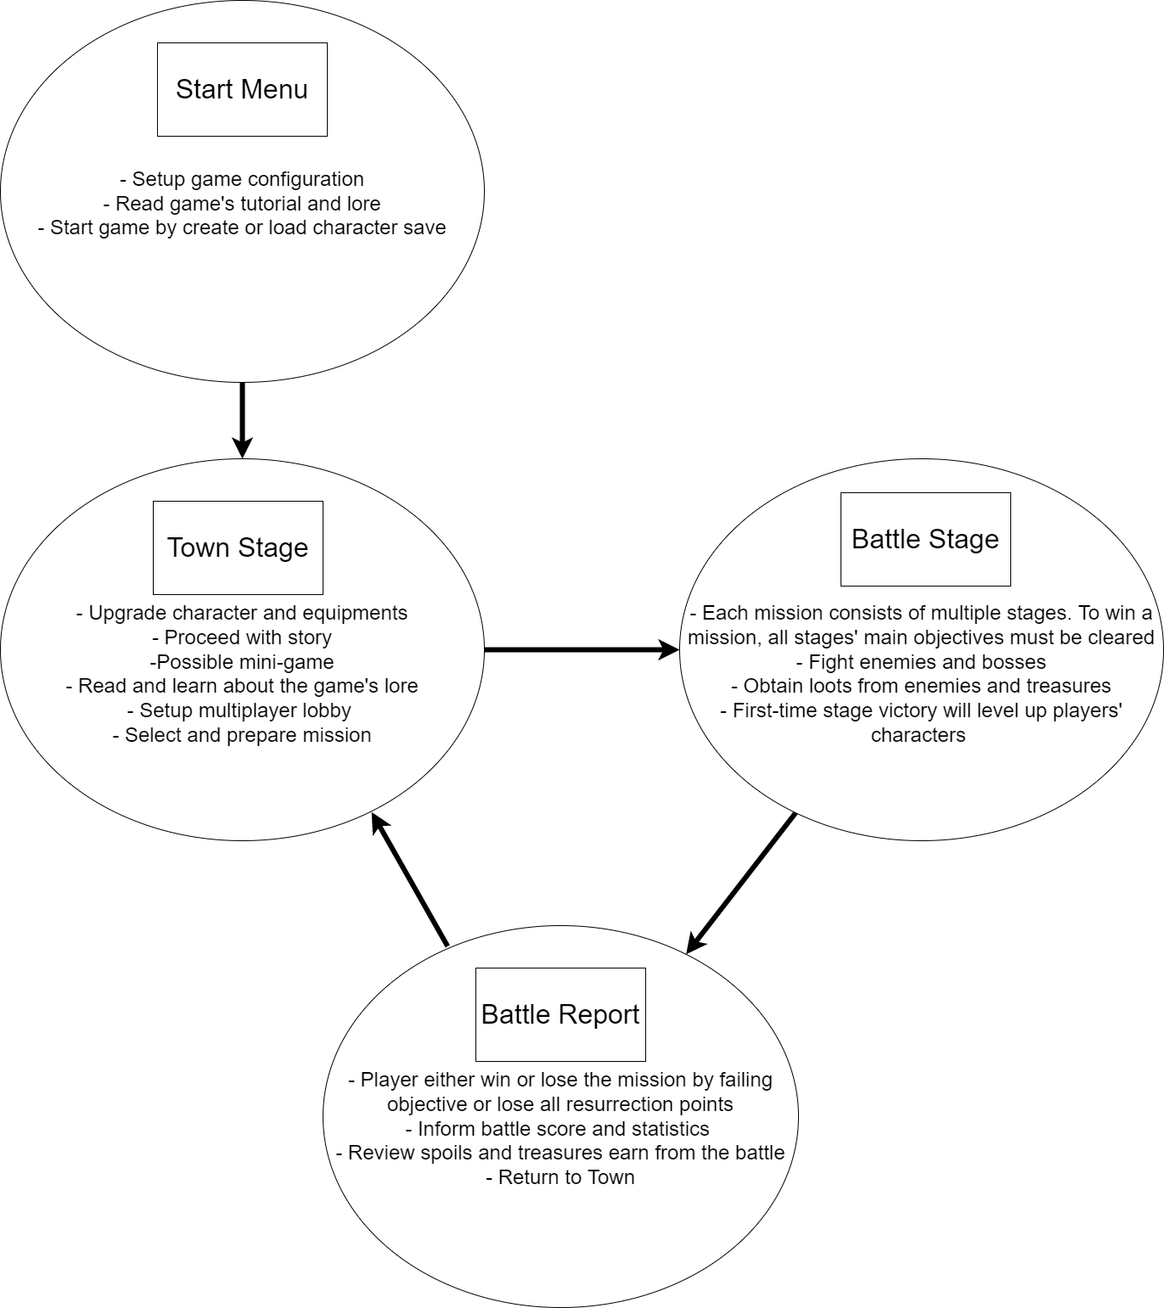

**Figure 4:** Summary of main gameplay loop

In addition to the fun value that the game can provide to players, the game also provides good detail of both fantasy lore and historical information for most of the elements in the game. The game will include an in-game encyclopaedia with a description of the game mechanism, leader, troop and so on. For examples, the stamina mechanic section will describe why and how morale plays a part in battle with historical examples.

# Summary Key Mechanic

- Simple to learn but difficult to master combat skill/combo

- Diverse cast of characters with unique gameplay mechanics

- Skill level up that is not simply damage number increase

- Random encounter and dynamic weather that affect players and enemies

- Equipment crafting system

- Pause and learn system, the player can pause the game and use a cursor to mouse over various in-game objects to learn about their historical information.

# **Story**

The game story starts with a prologue with simple and common tropes of many medieval fantasy genre stories. A hero on a glorious quest to defeat monsters and a dragon to save a kingdom. This prologue serves as the first/tutorial mission of the game that introduces various gameplay mechanics to the player. The player cannot fail this mission, as the hero will simply replenish his health right away each time he falls to the enemy's attacks.   
  
Once the player completes this prologue mission by killing a dragon, the main campaign will start, and the player can select a new hero from a list of 12 available characters. Again, the game's main story begins with the common tropes of a fantasy story, the King hires a group of heroes (the players) with a "Quest" to protect the kingdom against various threats in a series of chapters, from bandits, war, undead, and fantasy creatures. As the story progresses, players will learn more about the history of the character they are playing, the world itself, and the truth behind the "Quest".

# Development Plan

The game is developed in pure Python language using the Pygame library as its game engine for graphic, sound, and input systems. The game will use and adapt code and assets from the previous historical battle game (Project Masendor) for its foundation. A development demo should be ready after 6 months of development with the chapter 1 missions and 4 characters being playable.

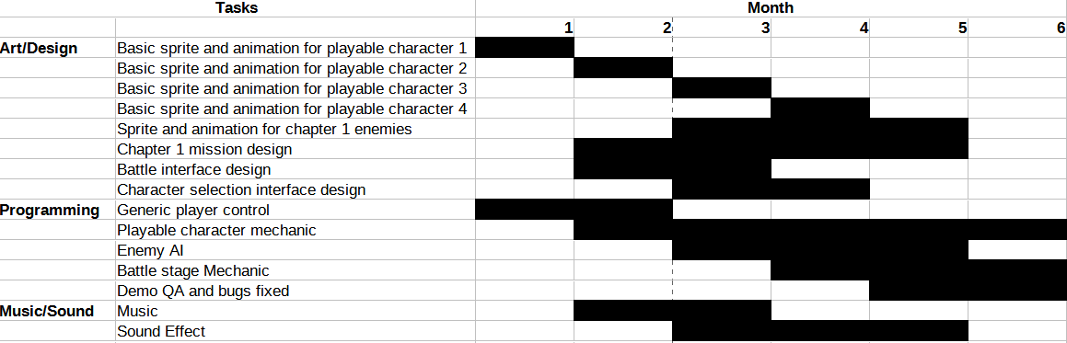

**Figure 5**: Demo development schedule

For the full development with dedicated development, the game should take no more than 2 years for the full release.

Below is a number summary of what the game should consist of in the full release version:

- 1 prologue chapter and 6 main story chapters with a number of bonus missions after the chapter story

Prologue, fairy tale art style?

1. Bandit threat in the kingdom, Western late medieval manuscript art style
2. War with nearby kingdoms, Western renaissance manuscript art style
3. Orc and goblin, Aztec+ tribal art style?
4. Undead, Western high medieval art style (mainly from Spanish/Greek manuscript)
5. Assassin, Black Hour book and Middle Eastern manuscript art style
6. Demon, mixed Christian + Indian + Buddhist art style

- 12 playable characters making up from 6 classes, 1 male and 1 female for each class. The character class signify the character play style, for example, a warrior class character is more focused on melee combat with superior defensive skill like parry and block while archer class character is focused on ranged combat.

- 4 difficulty levels: Story (easy), Normal, Macabre (difficult), End Game (very difficult)

**Figure 6**: Geographic Description of the Travels of the Apostles and the Journeys of Paul, Potentially can be adapted for mission selection interface



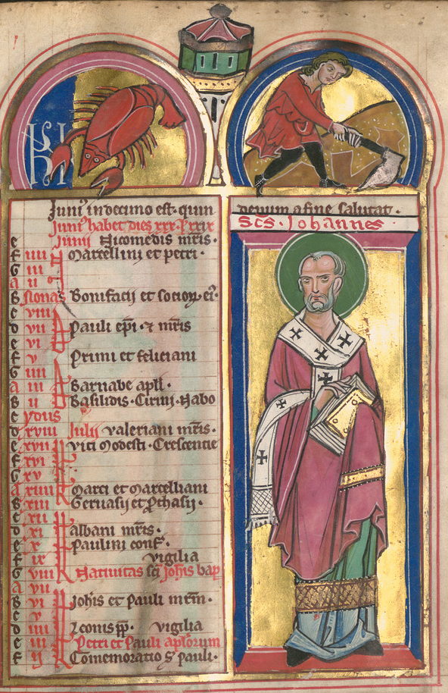

**Figure 7**: An illustration from Magdeburg Psalter Manuscript, Potentially can be adapted for character selection interface